Anthony Redamonti

Syracuse university

Homework 8

CIS-623 structured programming & formal methods

prof. Mehmet kaya

3/20/2022

Question 1:

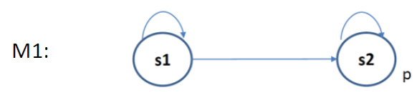

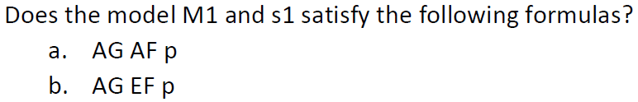

1. Not satisfied. All possible paths starting from s1 are s1’s infinite loop and s1->s2 then s2’s infinite loop. G means that every point along these two paths the following must be true: AF(p). S1’s infinite loop represents a path where F(p) is not true. Therefore, the answer is “not satisfied”.
2. Satisfied. All possible paths starting from s1 are s1’s infinite loop and s1->s2 then s2’s infinite loop. G means that every point along these two paths the following must be true: EF(p). E means that there must exist a path from the starting point where something must be true. F(p) means that there is a future path where p is true. S1 is connected to s2 and therefore always has the option of transitioning to s2, where p is true. The second path obviously satisfies the condition: EF(p). Therefore, the answer is “satisfied.”

Question 2:



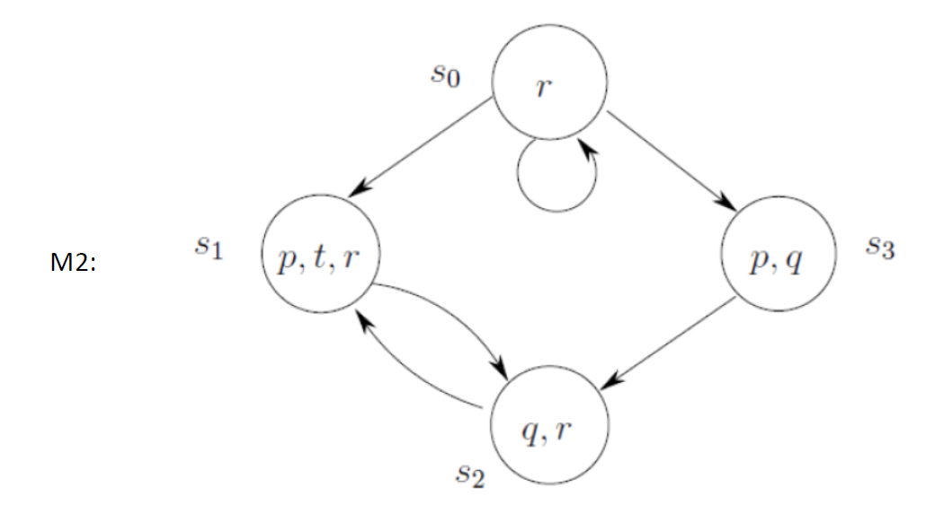

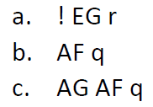

1. False. There is an infinite path where G(r) is true.
2. False. There is an infinite path where F(q) is false.
3. False. There is an infinite path where AF(q) is false (s0 recursive loop).

Question 3:

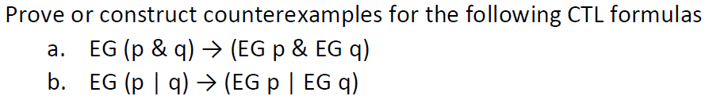

1. True. See proof below.

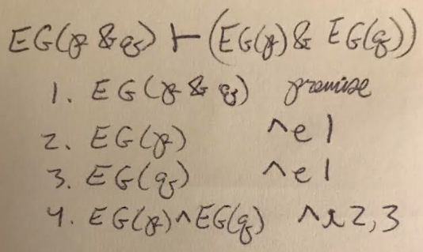

1. False. See counterexample below.

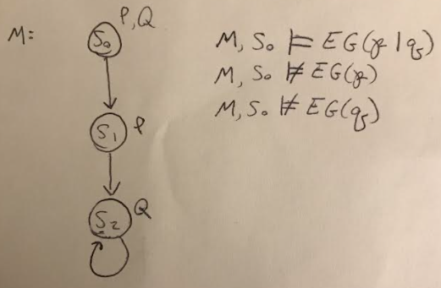

Question 4:

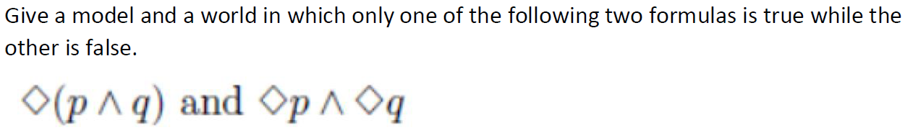

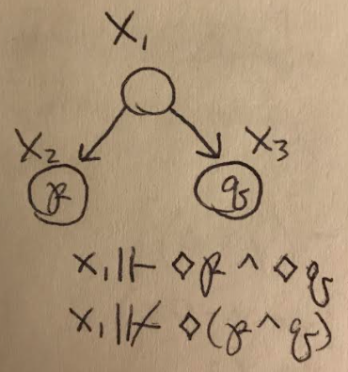

Question 5:

